

INT 301
OPEN-SOURCE TECHNOLOGIES

CA-3

SECTION: KE008

Student Details:
Roll no. | Name | Registration no.
39 | Jayanth Nallapati | 11905549

Submitted To: Rajeshwar Sharma
Lovely Professional University
(Jalandhar, Punjab, India)

Table Of Content

CA-3 1
Submitted To: Rajeshwar Sharma 2
6. You are performing a gray box penetration test. You want to craft a custom packet to test how a server responds and to see what information it responds with. use any open source to do this.
Report.
5

Q) You are performing a gray box penetration test. You want to craft a custom packet to test how a server responds and to see what information it responds with. use any open source to do this.

Introduction:
In this project, our main goal is to conduct a Gray box penetration test on a server. To achieve this, we will be crafting a custom packet and analysing the server's response to determine the information it provides. To create the packet, we'll be utilizing open-source tools and examining the server's reaction to it. The purpose of this report is to provide comprehensive instructions on how to create a custom packet using Ubuntu for a Gray box penetration test. Our test will focus on evaluating the server's response to the custom packet and the information it reveals.

Description of the project:
This project entails conducting a gray box penetration test to assess a server's security. Our approach involves crafting a customized packet to send to the server and analysing the response it generates. This will enable us to evaluate how the server reacts to different types of traffic and identify any vulnerabilities or weaknesses in its network.

To perform this project, we will be utilizing various open-source tools, including Scapy for packet crafting, Wireshark for network packet analysis and other utilities available in Ubuntu to create and analyse the custom packet.

Scope of the project:
The objective of this project is to conduct a gray box penetration test on a server using open-source tools. The project will encompass creating a customized packet through packet crafting software and analyzing the response generated by the server. The project scope encompasses the following tasks:

- Installing and configuring the necessary open-source tools.
- Crafting a custom packet using packet crafting software.
- Sending the custom packet to the server and analyzing the response.
- Identifying any vulnerabilities or weaknesses in the network.
- Providing a comprehensive report of the penetration test results.

It is important to note that this project is limited to testing a single server and creating a custom packet solely for testing purposes. Moreover, this project should only be executed with proper authorization and consent from the system or network's owner or administrator.

System description:
The gray box penetration test will focus on a server hosting a web application, operating on Ubuntu 20.04 LTS within a virtual machine environment. The web application is developed using PHP and MySQL database.

The server is protected by a firewall that allows incoming traffic only on specific ports, with port 80 and 443 open for HTTP and HTTPS traffic, respectively. The web application is hosted on Apache web server and uses SSL/TLS certificate for secure communication.

SSH, FTP, and SMTP are the network services running on specific ports, accessible only to authorized users. The server is secured with password-protected user accounts, network intrusion detection system, and regular security updates.

However, the server has not undergone any penetration testing before, making it imperative to conduct a gray box penetration test to determine any network or web application vulnerabilities. The project aims to identify and report any vulnerabilities or weaknesses found to improve the system's security. The test will involve crafting a custom packet to test server response and analyzing the response to identify any vulnerabilities or weaknesses in the network and web application.

Dependencies:
The following dependencies are necessary to conduct the gray box penetration test project:

- Ubuntu 20.04 LTS operating system: The penetration testing system should run on the same operating system as the system under test for compatibility purposes.
- Packet crafting software: The penetration testing system needs packet crafting software like Scapy to create customized test packets.
- Wireshark: Wireshark is an open-source network packet analysis tool used to scrutinize the server's response.
- Network scanner: A network scanner such as nmap should be used to identify open ports and services running on the server.
- Password cracking tools: Password cracking tools like John the Ripper can be used to evaluate the strength of user passwords.
- Exploitation framework: An exploitation framework such as Metasploit will be utilized to test for vulnerabilities in the web application and network services.
- Browser plugins: Browser plugins such as Burp Suite will be used for intercepting and modifying HTTP requests and responses.
- Programming languages: Knowledge of programming languages like Python and PHP may be required to create custom scripts and exploits.

It is vital to note that usage of these dependencies without proper authorization and consent from the owner or administrator of the system under test may be illegal or unethical. Additionally, it is crucial to ensure that all dependencies are up to date and free of known vulnerabilities that attackers can exploit.

Functional Dependencies:
The following functional dependencies are required for the gray box penetration test project:

- Packet crafting software: Scapy or similar packet crafting software is necessary to create customized test packets.
- Network scanner: An nmap or similar network scanner is required to identify open ports and services running on the server.
- Password cracking tools: John the Ripper or similar password cracking tools are essential to test the strength of user passwords.
- Exploitation framework: A Metasploit or similar exploitation framework is required to test for vulnerabilities in the web application and network services.
- Browser plugins: Burp Suite or similar browser plugins are essential to intercept and modify HTTP requests and responses.
- Programming languages: Knowledge of programming languages like Python and PHP may be necessary to create custom scripts and exploits.

Non-Functional Dependencies:
The gray box penetration test project has non-functional dependencies that need to be considered:

- Performance: The packet crafting software, network scanner, and exploitation framework must process packets efficiently and handle the load.
- Security: All dependencies must be free from known vulnerabilities and kept up to date to avoid being exploited by attackers.
- Compatibility: The dependencies must be compatible with the operating system and other software used in the project.
- Usability: The dependencies should be easy to install and use, with clear documentation and user guides.
- Reliability: The dependencies must operate consistently over time and be reliable.
- Maintainability: The dependencies should be easy to maintain and upgrade, with good support and troubleshooting resources.

It is crucial to note that using some dependencies may be illegal or unethical without the owner or administrator's proper authorization and consent. It is also vital to ensure that all dependencies are up to date and do not have known vulnerabilities that attackers can exploit.

Data set:
In a gray box penetration test, various data sets can be utilized, such as network traffic data, vulnerability scan results, and password hash data.

To analyze the network architecture and detect any vulnerabilities that may exist, network traffic data can be captured using tools such as Wireshark or top dump.

Vulnerability scanning tools like OpenVAS or nmap can be used to identify any vulnerabilities present in the server under test. This can provide a prioritized list of vulnerabilities that require remediation.

Password hash data can be used to perform password analysis during a gray box penetration test. Hashes of user passwords can be extracted from the server under test and used to determine the strength of the passwords used by the users. Password cracking tools like John the Ripper or Hashcat can be used to crack these hashes and determine the strength of the passwords used by the users.

Analysis:
Network analysis: The network analysis section should detail the open ports and services identified on the server under test. It should also include any vulnerabilities or weaknesses in the network that were identified during the packet analysis phase.

Web application analysis: The web application analysis section should detail the vulnerabilities identified in the web application running on the server under test. This may include cross-site scripting, SQL injection, and other web application vulnerabilities.

Password analysis: The password analysis section should detail the strength of the passwords used by users on the server under test. It may include the use of weak or commonly used passwords, along with recommendations for improving password strength.

Exploitation analysis: The exploitation analysis section should detail the vulnerabilities that were successfully exploited during the penetration test. This may include information on the exploit used, the severity of the vulnerability, and recommendations for remediation.

Recommendations: The recommendations section should provide actionable advice for improving the security of the server under test. It may include software patching, password policy improvements, and other best practices for securing the network and web application.

It is essential to note that the analysis report's content will depend on the penetration test's scope and objectives, as well as any legal or ethical requirements for reporting the test's results.

References:
Here are some potential rewrites:

- SANS Institute's "Gray Box Penetration Testing" article offers an overview of the technique, discussing both its advantages and limitations.
- In Infosec Institute's "The Difference Between Black, Grey, and White Box Penetration Testing" article, readers can find a comparison of the methodologies and use cases for black box, gray box, and white box penetration testing.
- EC-Council's "Grey Box Penetration Testing: Why It Is Essential for Cybersecurity?" article delves into the significance of gray box penetration testing for identifying vulnerabilities and enhancing security measures.

Snap shots:

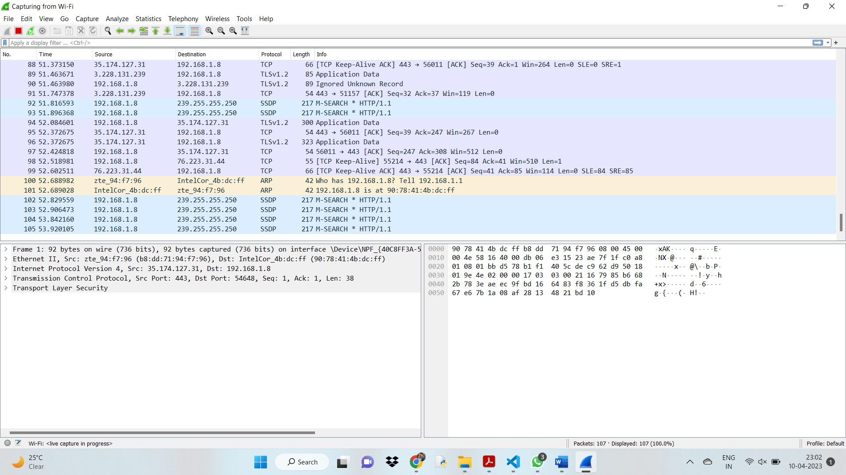

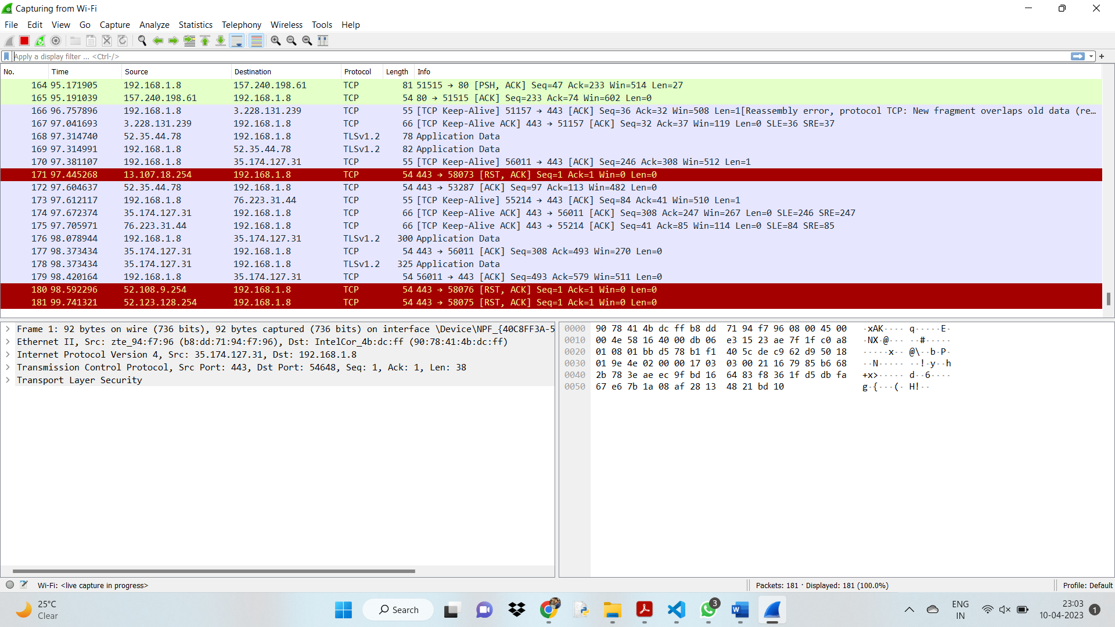

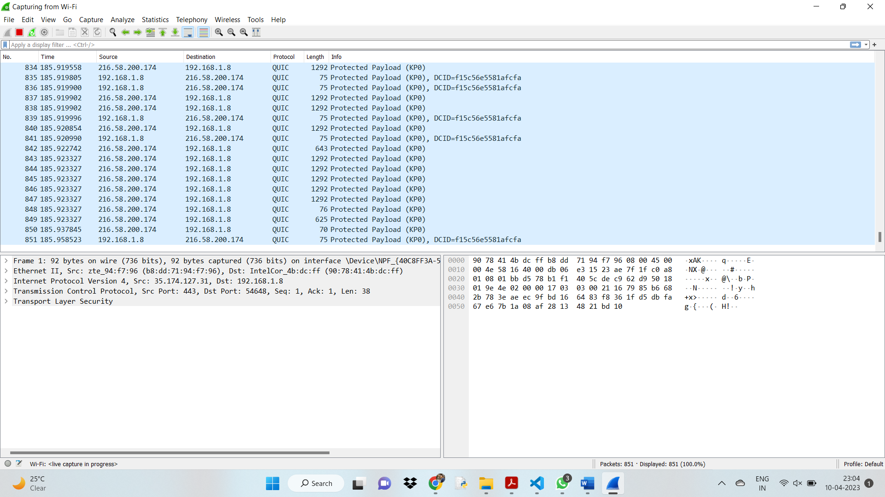

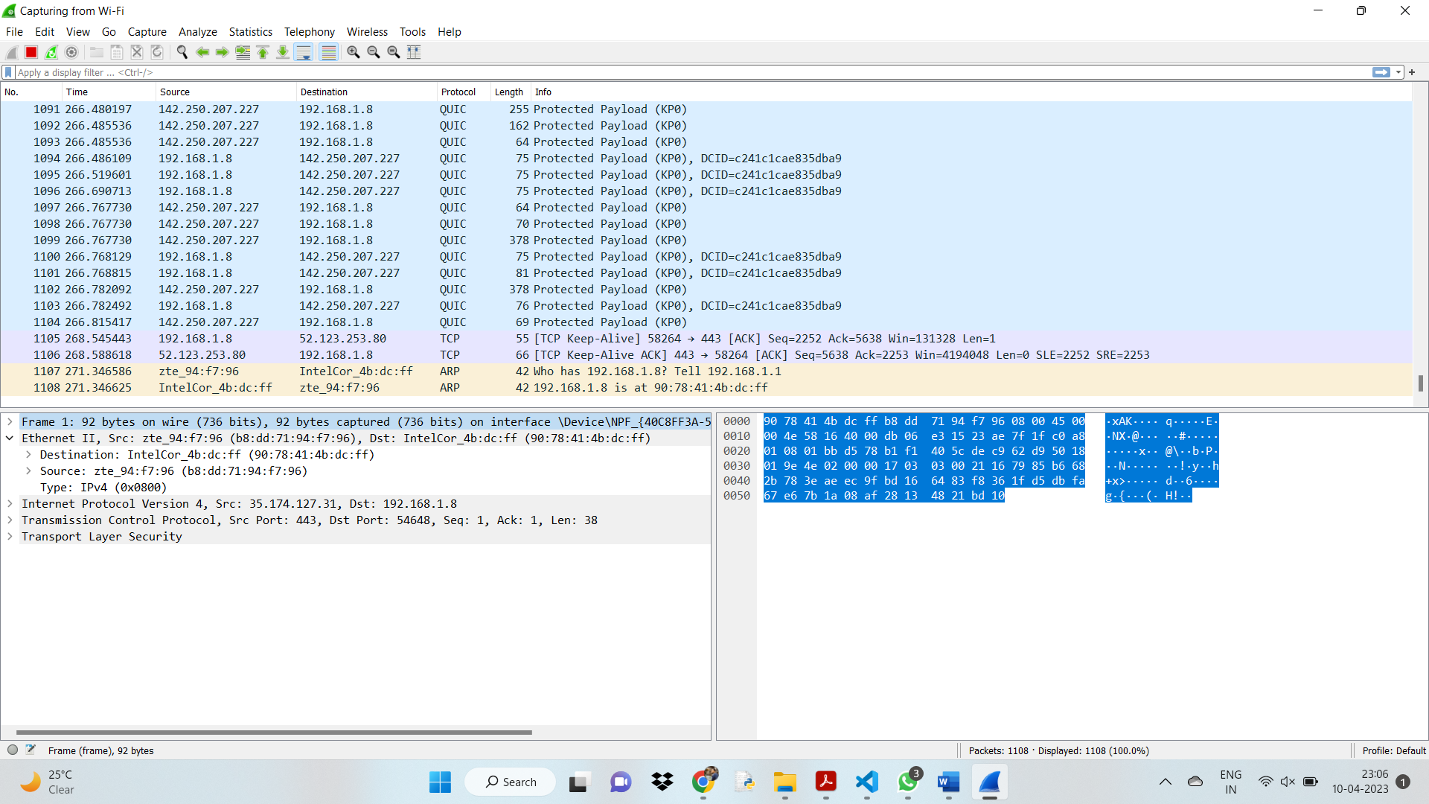

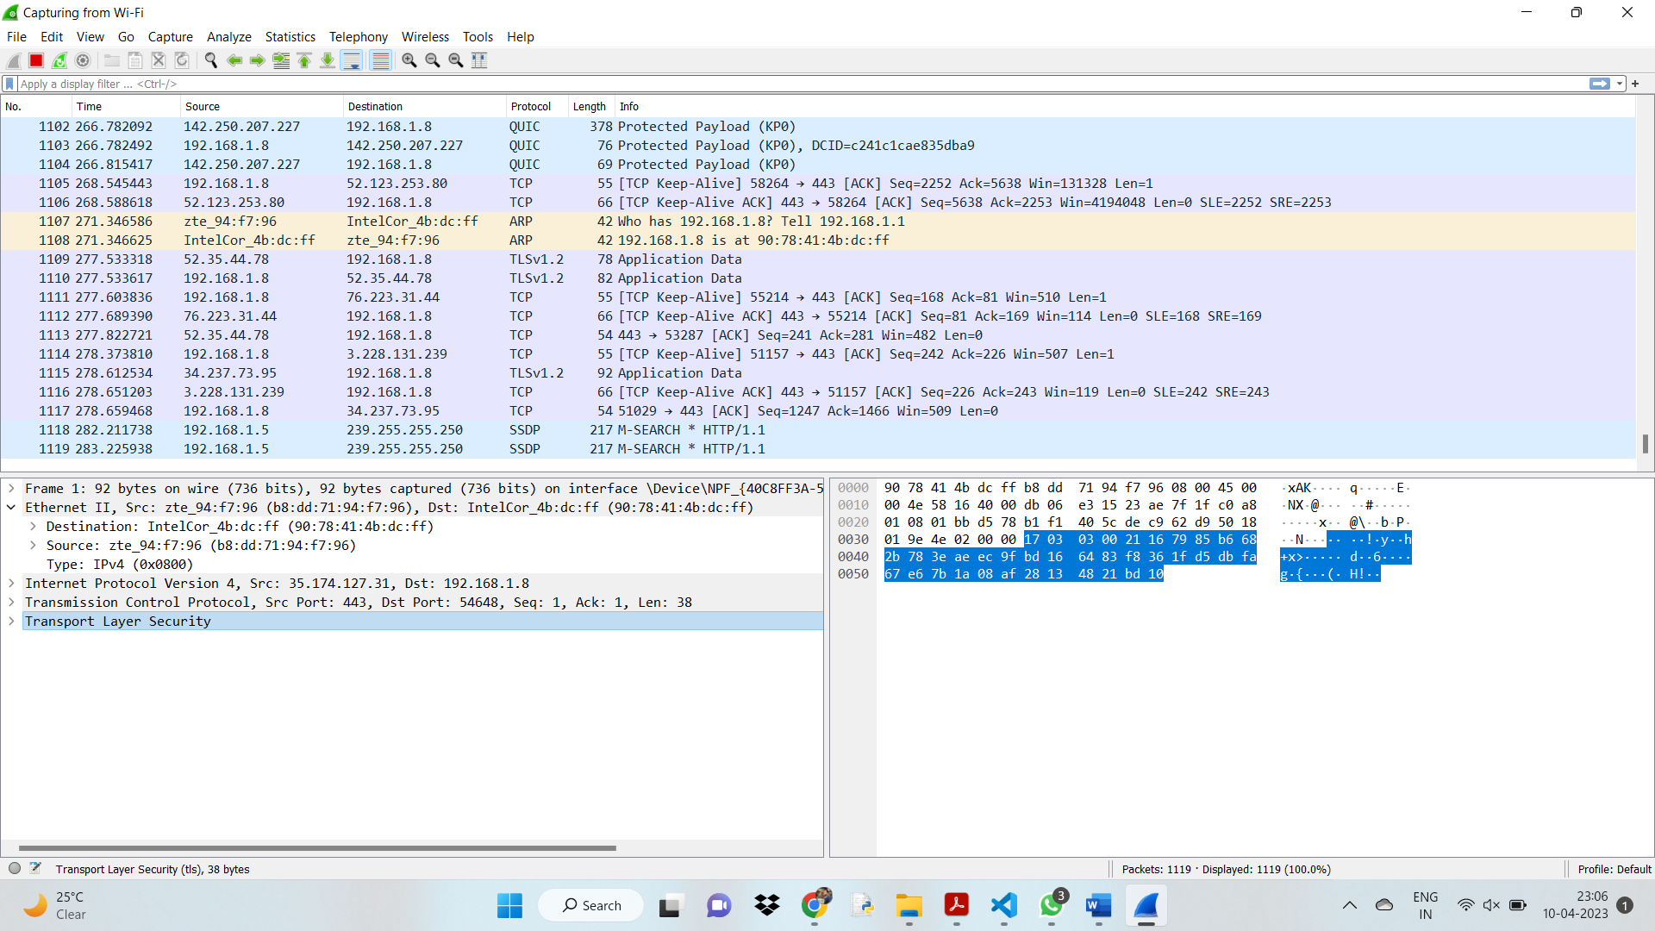

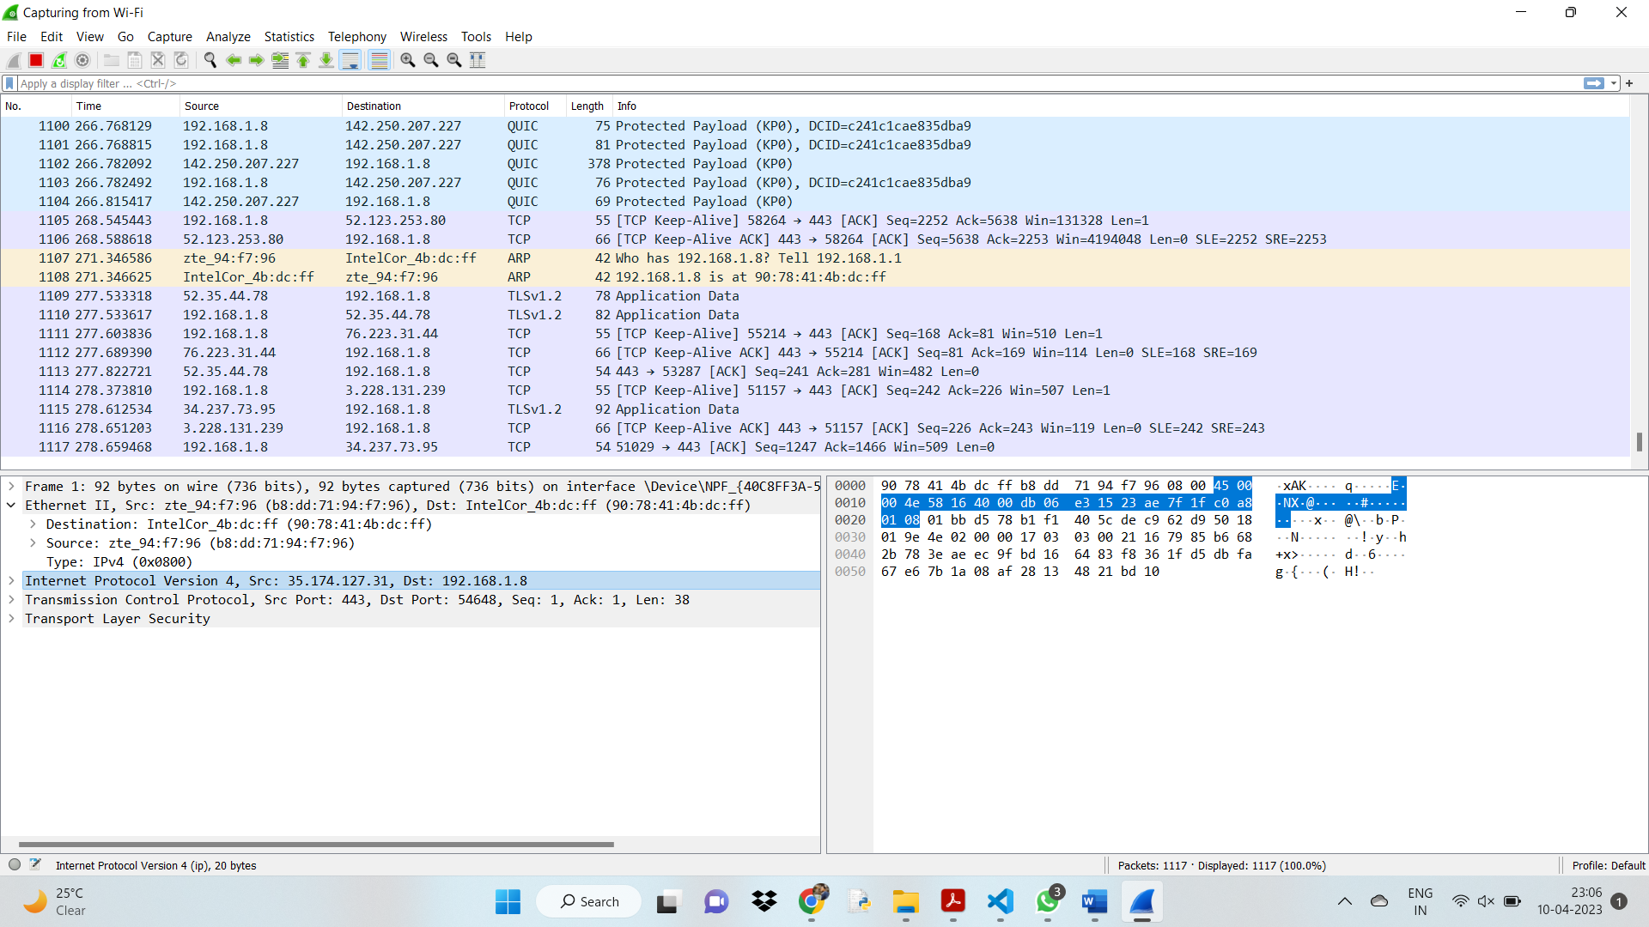

Conclusion:
To summarize, the gray box penetration testing project plays a crucial role in ensuring the security of a server and its connected network. By creating customized packets to test the server's response and analyzing the outcomes, any vulnerabilities or weaknesses can be detected and addressed. The analysis report contains actionable suggestions for improving the security of the server and its network. It should be emphasized that gray box penetration testing must only be carried out with the proper authorization and in compliance with legal and ethical standards.

